**23CSE111**

**LAB MANUAL**



**Department of CSE**

**Amrita School of Engineering**

**Amrita Vishwa Vidyapeetham, Amaravati Campus**

**Verified By :- Name: G.lakshmi karthikeya**

**Roll No: 24049**

|  |  |  |  |  |
| --- | --- | --- | --- | --- |
| S.NO | Programs | Date | Pg:No | Signature |
| 1 | 1. Download and Install Java Software. 2. Write a java program to print message “Welcome to java programming”. 3. Write a java program that prints name, roll number, section of a student. |  |  |  |
| 2 | i. To calculate the area of the rectangle  ii. Program to convert the temperature in celsius to Fahrenheit.  iii. Program to calculate the simple interest.  iv. Program to find the largest of three numbers using the ternary operators.  v. Program to find the factorial of the number |  |  |  |
| 3 | i. Create the java program for the cars with constructor and methods.  ii. Create the java program to withdraw and deposit money in the bank account. |  |  |  |
| 4 | i. Create the java program for the books by using the constructor and display its details using methods.  ii. Program to explain the final and the static variables. |  |  |  |
|  |  |  |  |  |
|  |  |  |  |  |
|  |  |  |  |  |
|  |  |  |  |  |

***Week 1:-***

# Program-1:-

## Aim:-Download and Instal the Java Software Procedure Step-1:- Type Java download in search

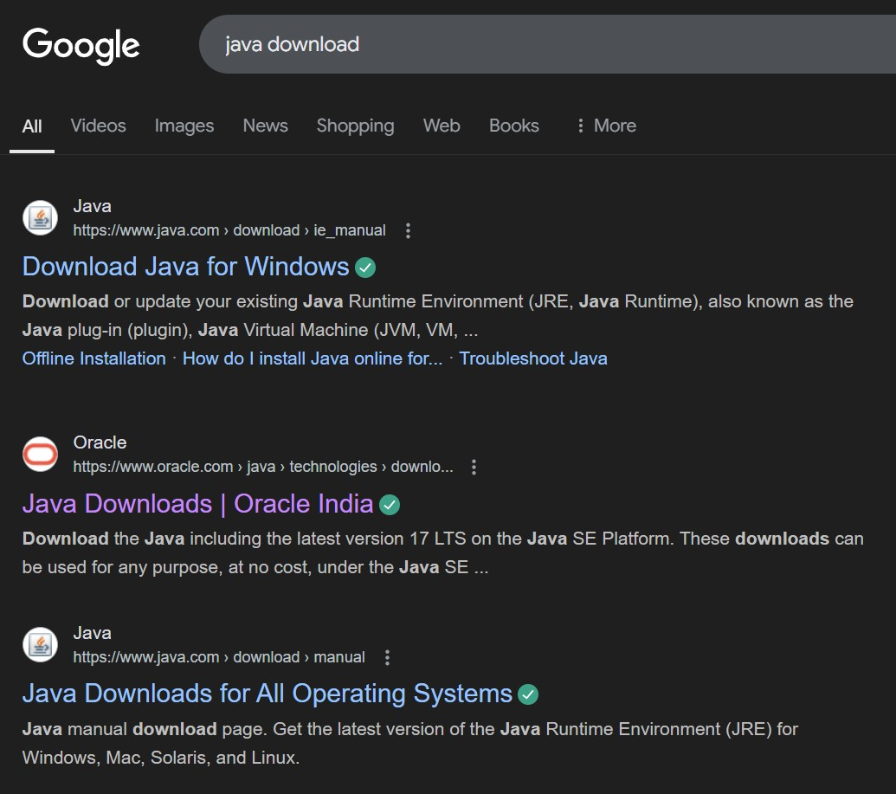

## Step-2:-click on oracle java download and enter into oracle website

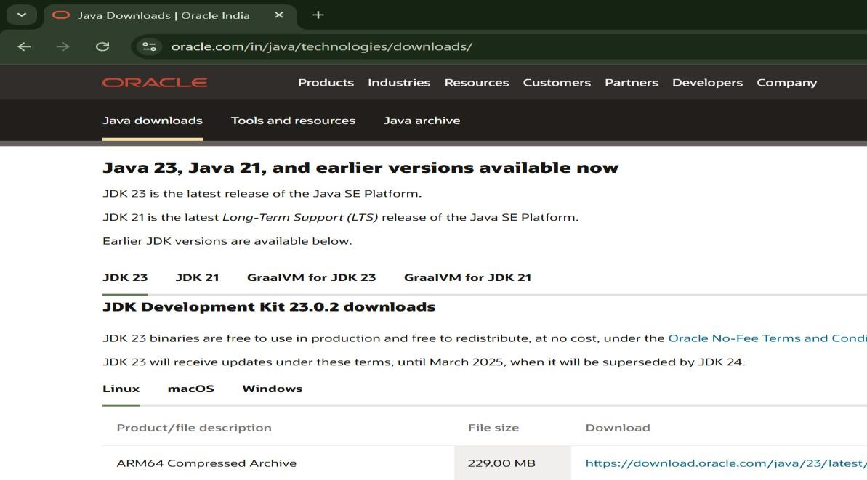

## Step-3:-click on JDK21 and click on windows and later click on x64 instalier link to download

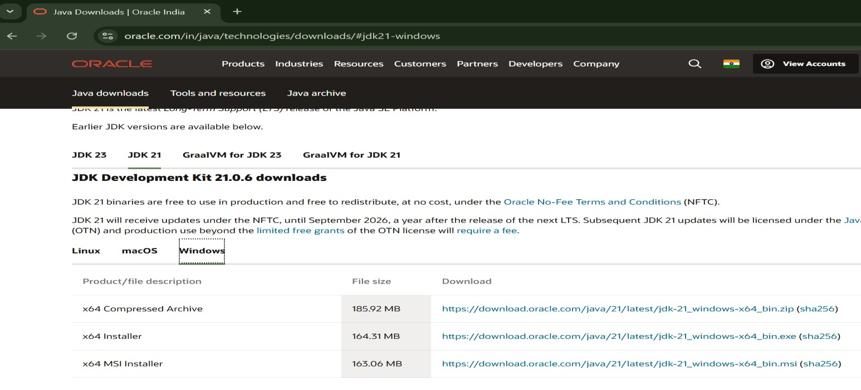

## Step-4:-After completing download click on it’s file and then give permission to install

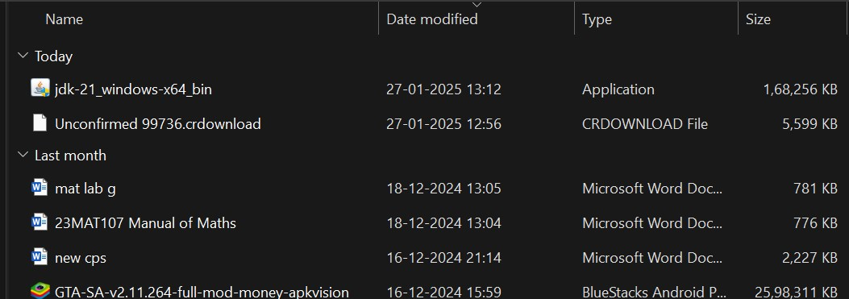

Step-5:-Then go to (This pc) in that click (windows{c}) in that click (Program files) in that click (Java) in that click (jdk-21) in that click (bin)

## Step-6:-Select and copy path of opening the file and then press windows and search System Environmental

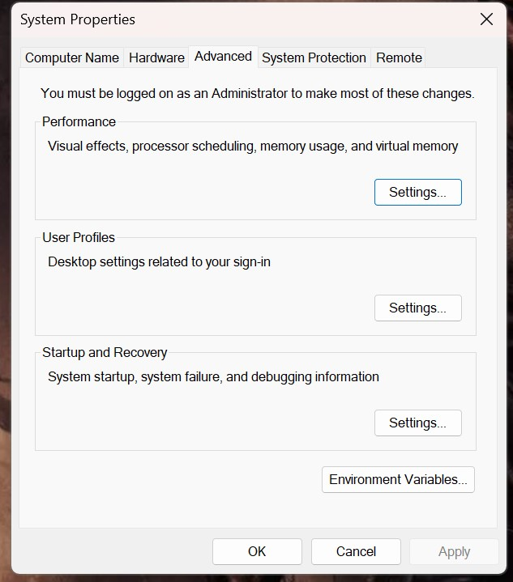

Step-7:-After opening Environment variables then past path of opening file in user variable and click on ok

## Step-8:-To verify version open CMD and type java --version

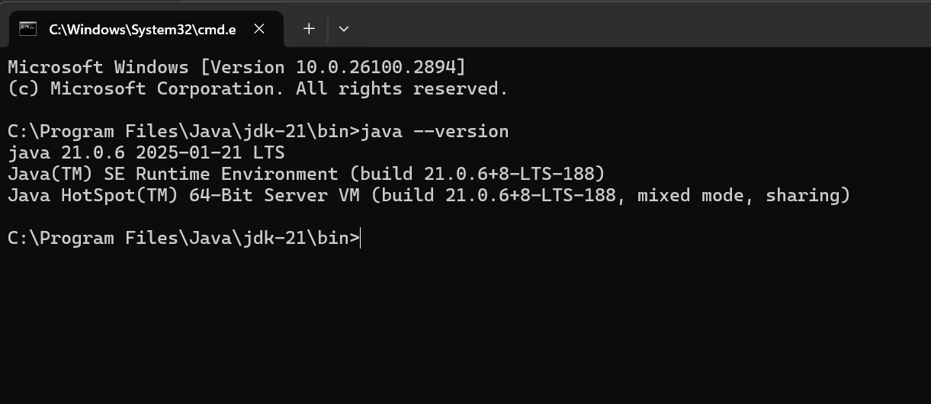

**Program : 2**

## Aim:-write a java program to print[welcome to java programming Input:-

class ex_1{

public static void main(String[] args){

System.out.println("welcome to java programming");

}

}

## Output:-

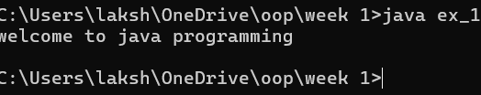

### Program : 3

Aim:-write a java program that prints name, roll no, section of the student Input:-

class Studentdet{

public static void main(String[] args){

System.out.println("Name: G.l.karthikeya”);

System.out.println("Class: CSE A");

System.out.println("Roll No: 24049");

}

}

### Output:-

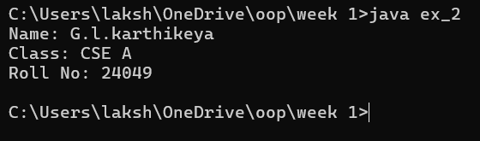

***WEEK-2***

Program-1:

Aim: to write a java program to find area of rectangle

Input:

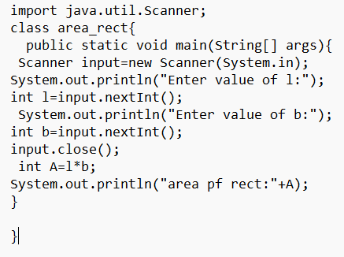

Output:

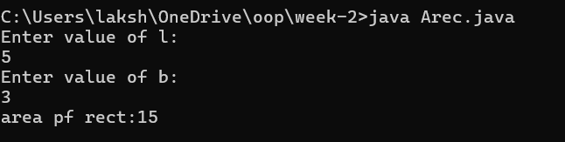

Error table:

|  |  |  |
| --- | --- | --- |
| Error | Error cause | Error rectification |
| error: ';' expected | ‘;’ is missed in the end of print statement | Placed ‘; ’ at the end of the statement |
| error:cannot find symbolScannerinput=new scanner(System.in); | Placed small s in place of capital S | Replaced capital s in place of small s to rectifiy the error |
| error: cannot find symbol  int b=input.nextstr(); | Placed str in place of int | Rectified by replacing int in place of int |

Program-2

Aim: write a java program to convert temp from celsius to farenheit

Input:

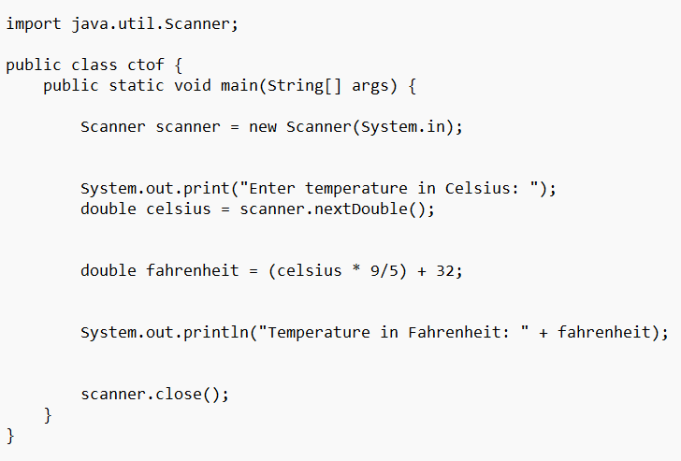

Output:

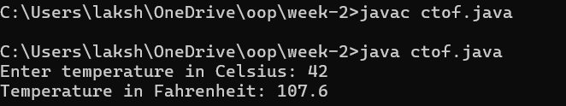

Error table:

|  |  |  |
| --- | --- | --- |
| Error | Error cause | Error rectification |
| error: ';' expected  public static void main(String[] args) | Forgot flower brace in the end | Rectified by replacing flower brace |
| error: ';' expected  scanner.close() | Forgot ‘;’ at the end the statement | Rectified by placing ’;’  it |
| error: incompatible types: possible lossy conversion from double to int  int celsius = scanner.nextDouble(); | Placed int in place of double | Rectified by replacing double |

Program-3:

Aim: write a java program to calculate simple interest

Input:

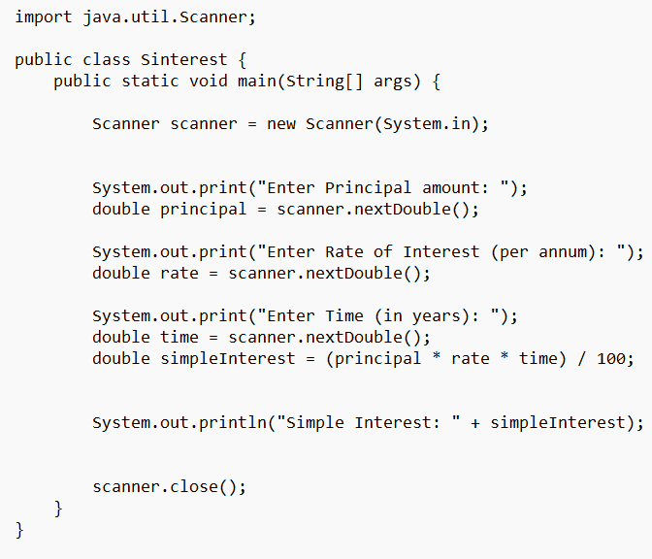

Output:

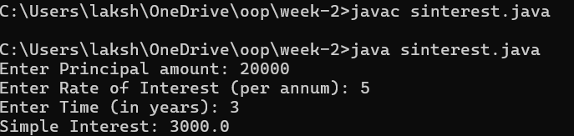

Error table:

|  |  |  |
| --- | --- | --- |
| Error | Error cause | Error rectification |
| error: class Sinterest is public, should be declared in a file named Sinterest.java  public class Sinterest {  ^ | Placed capital s I place of small ‘s’ | Replaced by placing small ‘s’ |

Program-4

Aim: write a java program to find the largest of 3 numbers using terenary operator

Input:

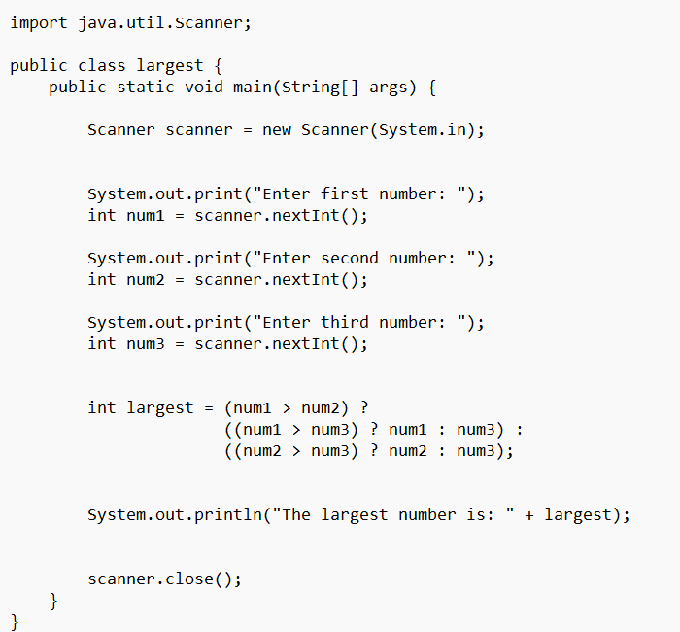

Output:

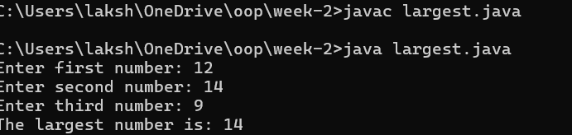

Error table:

|  |  |  |
| --- | --- | --- |
| Error | Error cause | Error rectification |
| error: reached end of file while parsing  ((num1 > num3) ? num1 : num3) | Missed ‘} ’ in the end of the program | Rectified by replacing it |
| error: illegal start of expression  }  ^ | Missed’}’in the starting | Rectified by replacing it |

Program-5

Aim: write a java program to find the factorial of a number

Input:

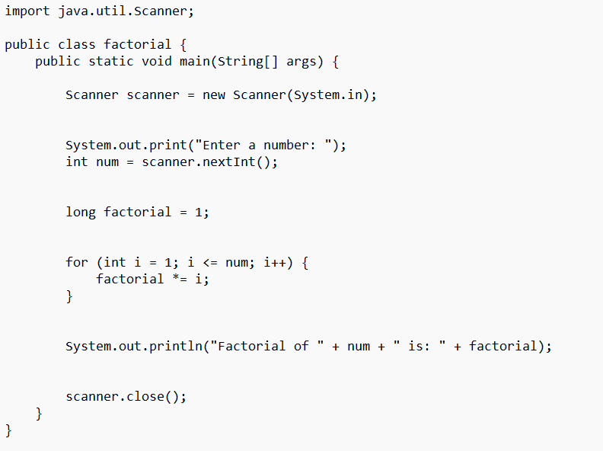

Output:

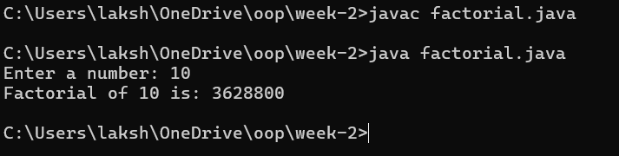

Error table:

|  |  |  |
| --- | --- | --- |
| Error | Error cause | Error rectification |
| error: unclosed string literal  System.out.print("Enter a number: );  ^ | Missed “ in the end | Rectified by replacing “ |

***Week-3***

**Aim: (i)** Create the java program for the cars with constructor and methods

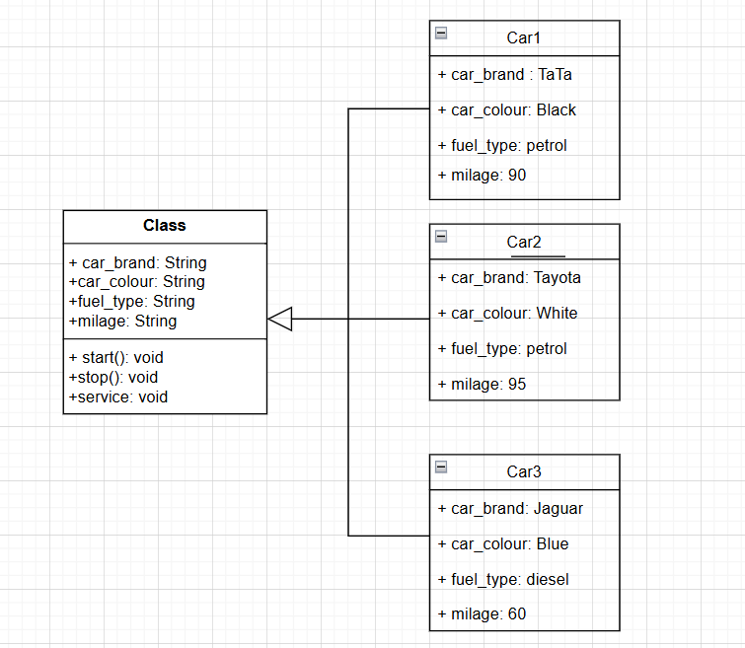

Program:

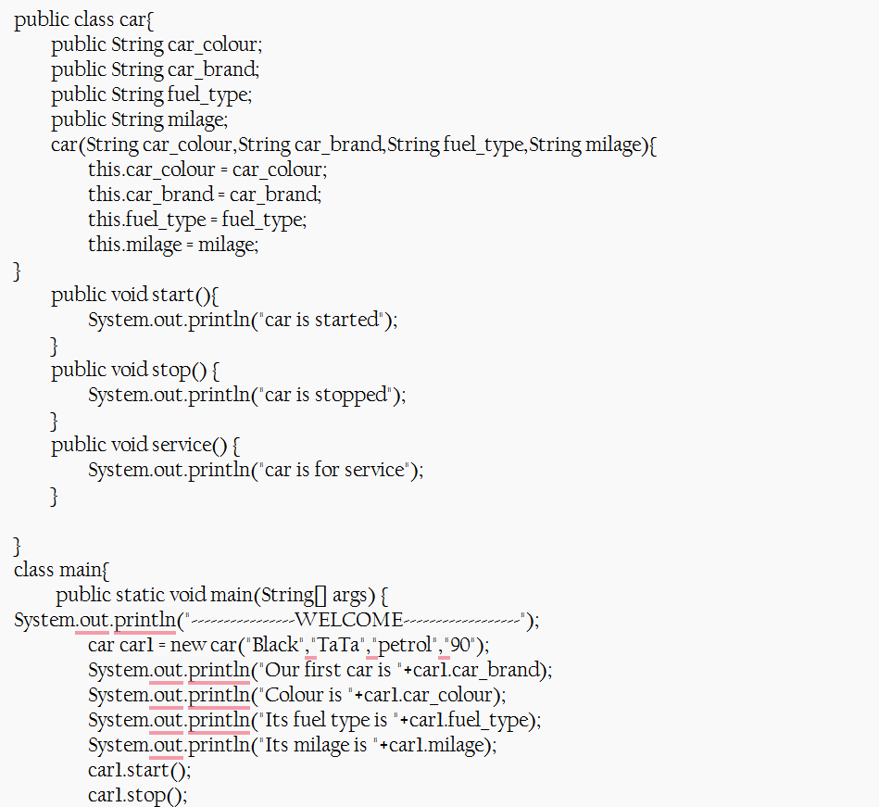

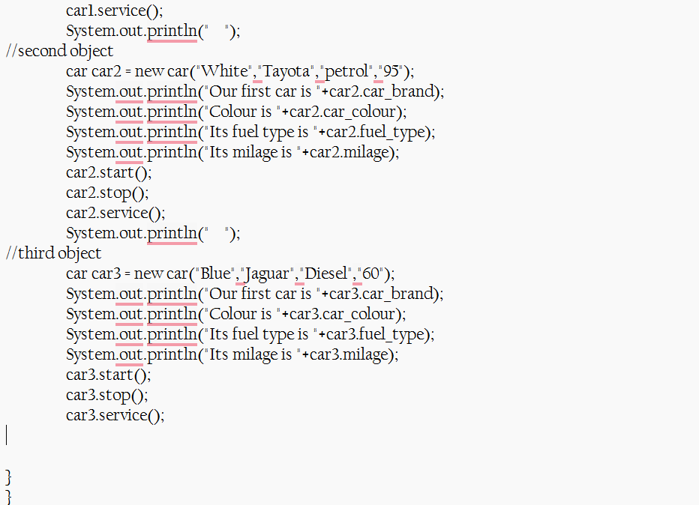

Output:

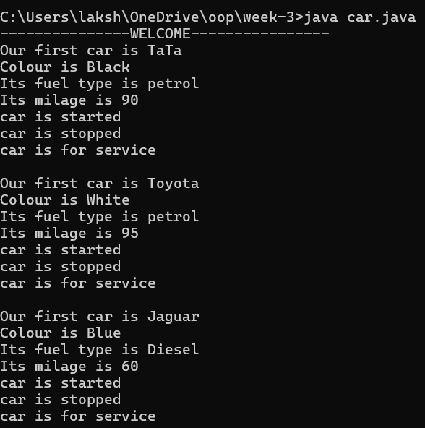

**Error:**

|  |  |  |
| --- | --- | --- |
| **Error Type** | **Incorrect Code** | **Corrected Code** |
| **Class Naming Issue** | class main{ | class Main{ |
| **Incorrect Object Description** | "Our first car is "+car2.car_brand; | "Our second car is "+car2.car_brand; |

**Aim: (ii)** Create the java program to withdraw and deposit money in the bank account.

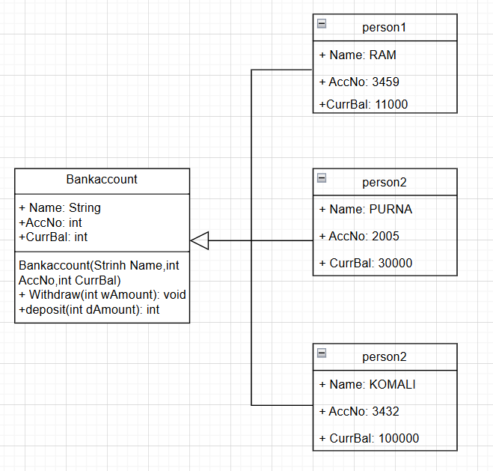

Program:

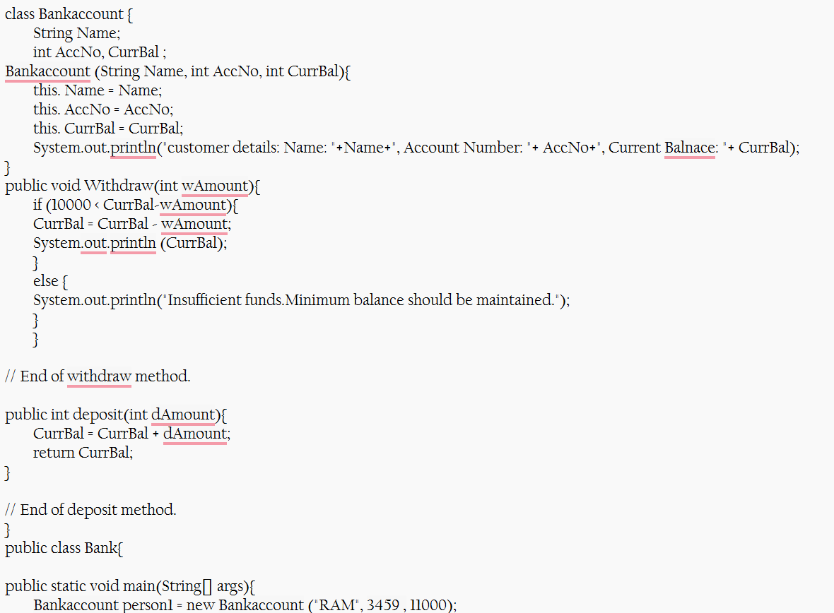

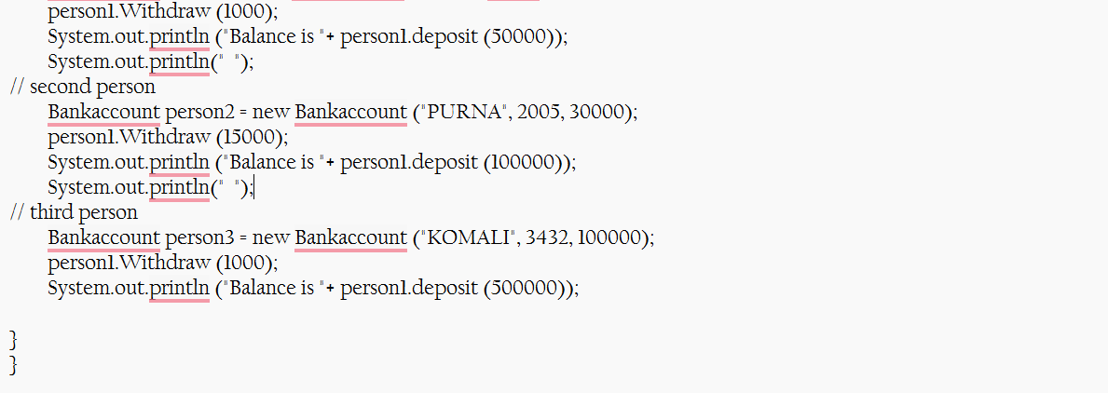

Output:

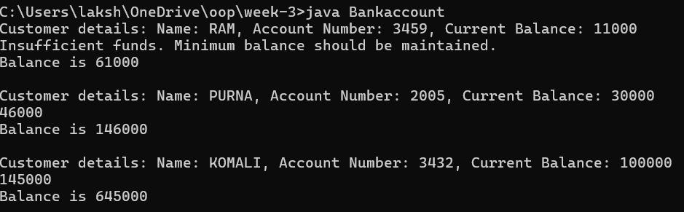

**Error:**

|  |  |  |
| --- | --- | --- |
| **Error Type** | **Incorrect Code** | **Corrected code** |
| **Class Name Capitalization** | class Bankaccount | class BankAccount (Java follows PascalCase for class names) |
| **Object Naming Issue** | BankAccount person-1 (hyphen is not allowed) | BankAccount person1 |
| **Missing Semicolon** | System.out.println ("Balance is "+ person-1.deposit (50,000)) | System.out.println ("Balance is "+ person1.deposit (50000)); (semicolon added) |

***Week-4:***

**Aim:** (i) Create the java program for the books by using the constructor and display its details using methods

**Procedure:**

Code:

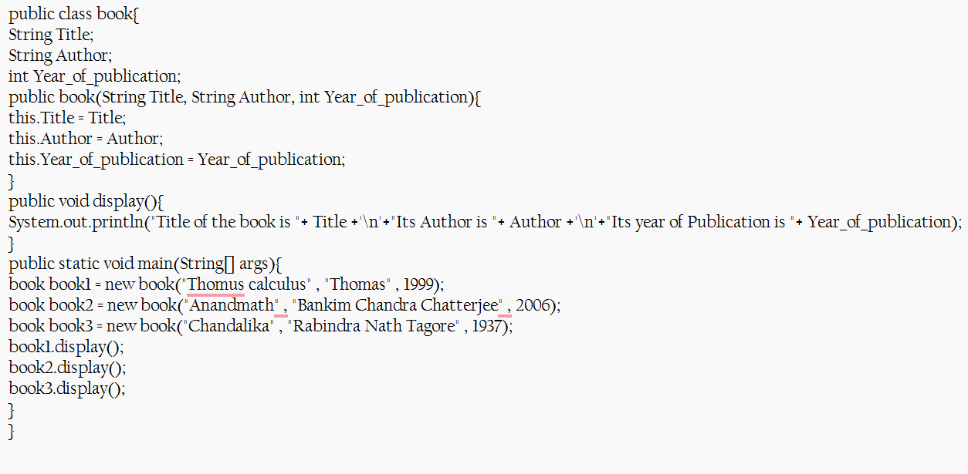

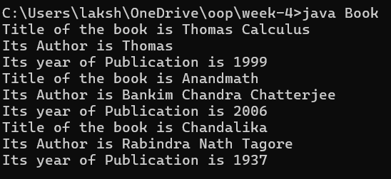

**Errors:**

|  |  |  |  |  |
| --- | --- | --- | --- | --- |
| **Error Type** | |  | | --- | | **Incorrect Code** |  |  | | --- | |  | | **Corrected Code** |
| **Class Name Capitalization** | public class book | public class Book (Java follows PascalCase for class names) |
| **Constructor Name Mismatch** | new book(...) | new Book(...) (Constructor name must match class name) |

**Aim: (ii)** Program to explain the final and the static variables.

**Class Diagram:**

Code:

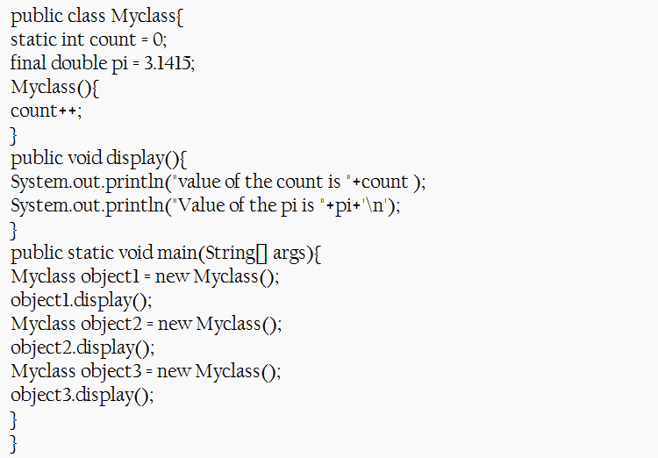

Output:

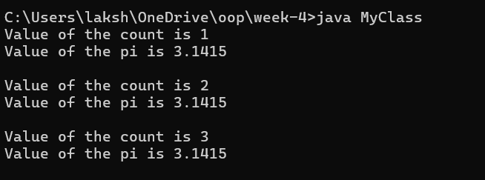

**Error:**

|  |  |  |
| --- | --- | --- |
| **Error Type** | **Incorrect Code** | **Corrected Code** |
| **Attempt to Modify final Variable** | pi = 3.14; (if added inside the constructor or method) | Remove this line (final variables cannot be reassigned) |
| **Incorrect Class Name** | public class Myclass | public class MyClass (Java follows PascalCase for class names) |